Lab-1
1.Log in as the root user. 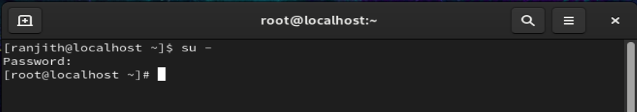

2.Create a user named `student`.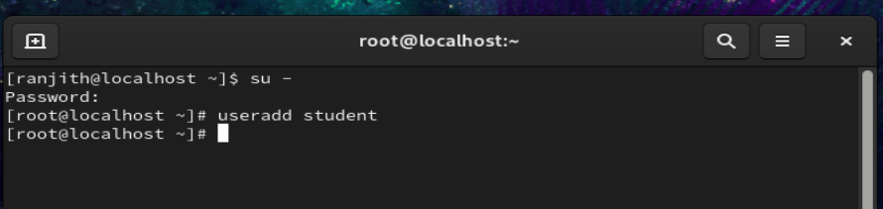
3.Verify that the user `student` exists in the system.

4.Switch from root to the `student` user.

5. Verify the currently logged-in user. 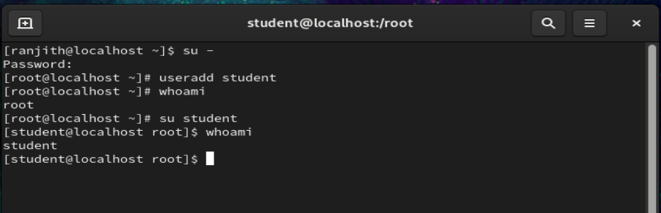
6. Exit from the `student` user.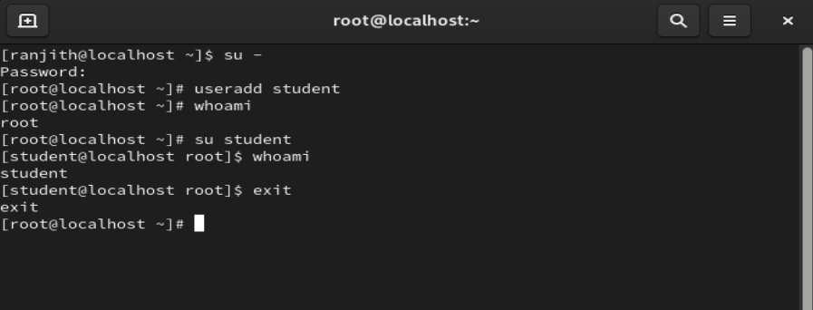

7. Exit from the root user.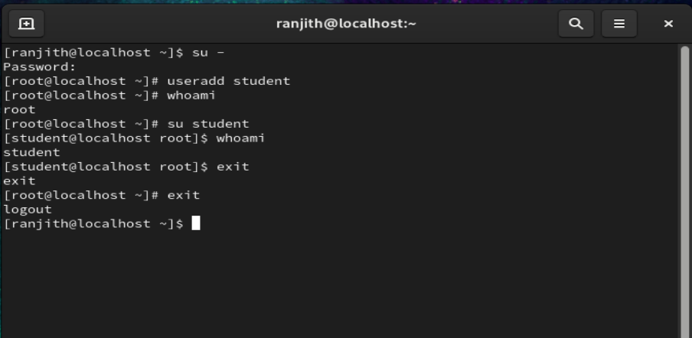

Lab2
- Create a directory named `dir1`.
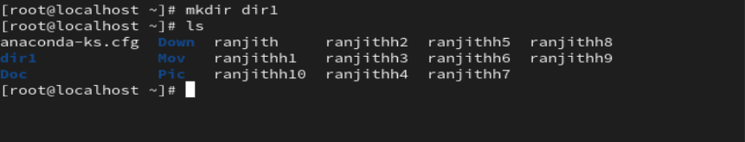

- Create multiple directories `dir2`, `dir3`, and `dir4` using a single command.
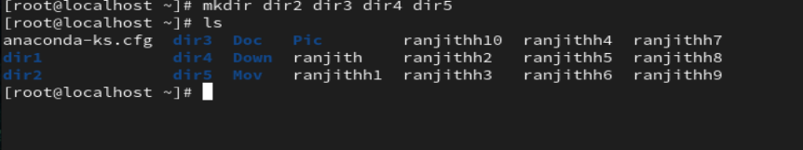
- Create directories named `docs`, `images`, and `videos`.
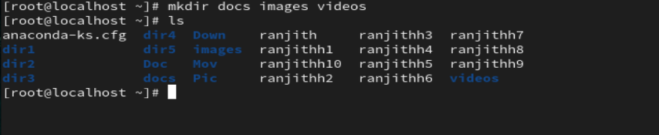
- List all created directories.
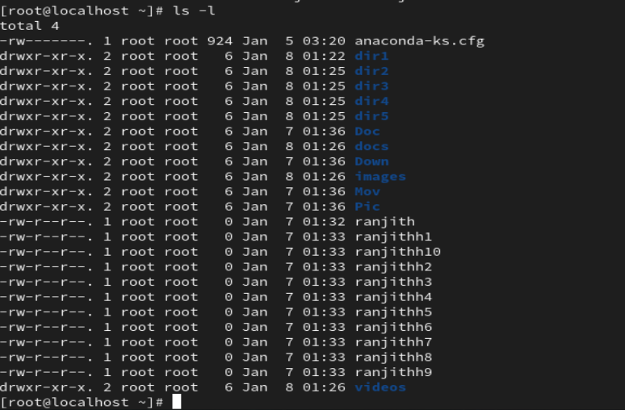
- Try creating a directory that already exists and observe the result.

Lab 3
- Create a file named `file1.txt`.
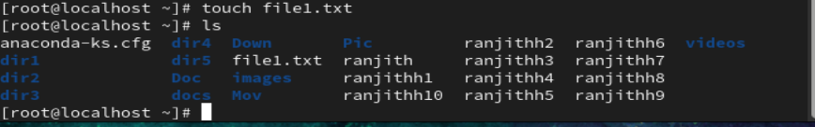
- Create multiple files `file2.txt`, `file3.txt`, and `file4.txt` using one command.
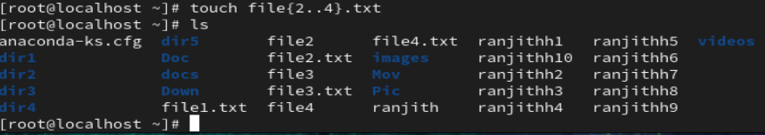
- Create files named `log1`, `log2`, and `log3`.
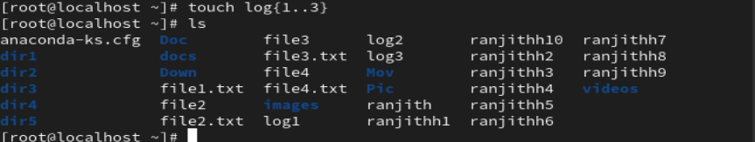
- Update the timestamp of `file1.txt`.
- Verify the files created.
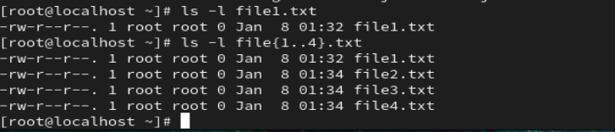

Lab-4

- Change directory to the home directory.
- Change directory to `/home`.
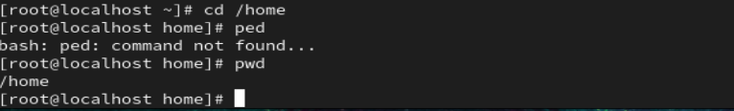
- Change directory to `/etc`.
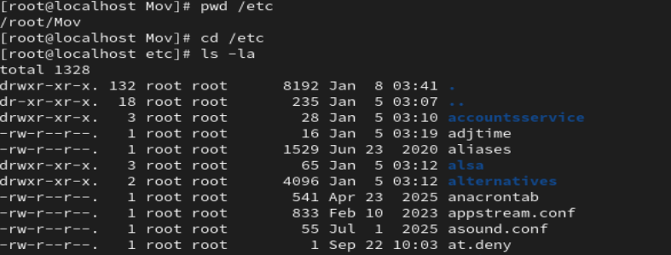
- Return to the previous directory.
- Move one directory up from the current directory.
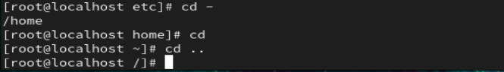

Lab -5
- List files and directories in the current directory.
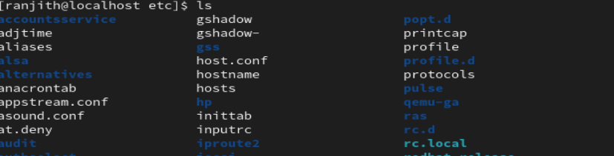
- List files of the `/etc` directory.
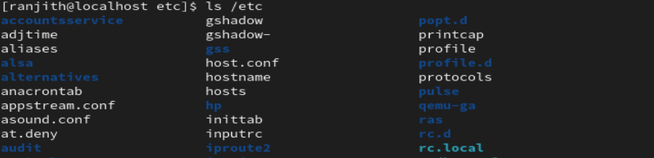
- List all files including hidden files.
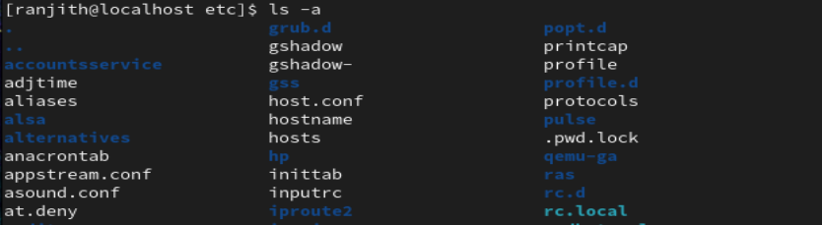
- Display files in detailed format.
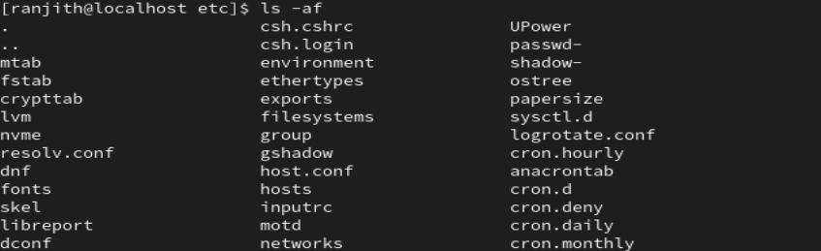
- Identify file permissions, owner, and size from the output.
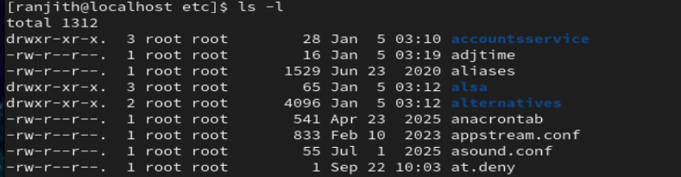

Lab -6
- Create an empty directory named `emptydir`.
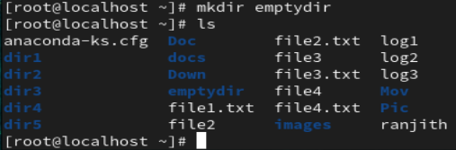

- Remove the directory `emptydir`.
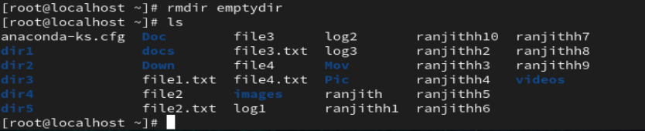
- Create two empty directories `test1` and `test2`.
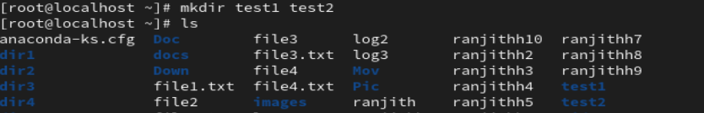
- Remove both directories using a single command.
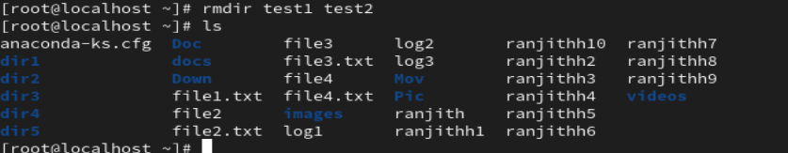
- Try removing a non-empty directory using `rmdir` and observe the result.
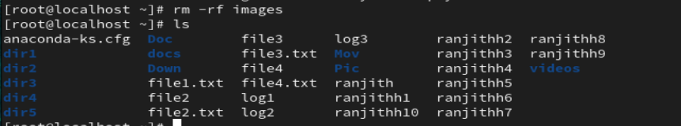

Lab -7
- Create a file named `oldfile.txt`.
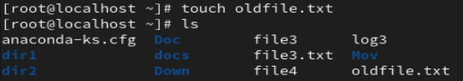
- Remove the file `oldfile.txt`.
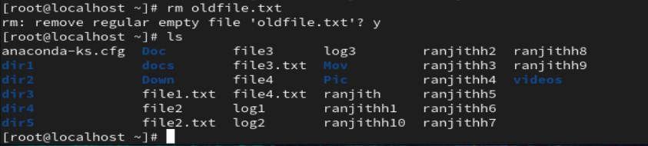
- Remove multiple files `file2.txt` and `file3.txt` using one command.
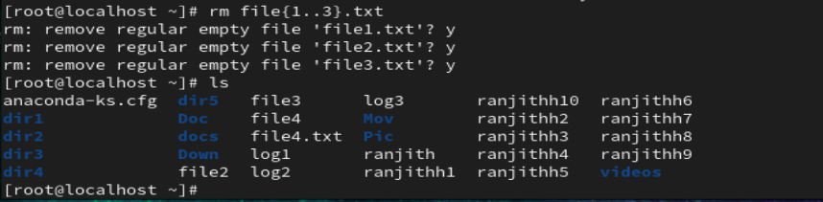
- Try removing a directory using only `rm` and observe the result.

Lab -8

- Create a directory named `mydir`.
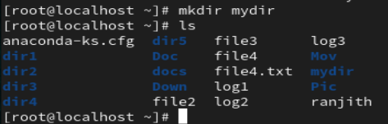
- Create files inside `mydir`.
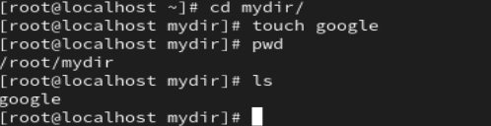
- Remove `mydir` using a recursive delete command.
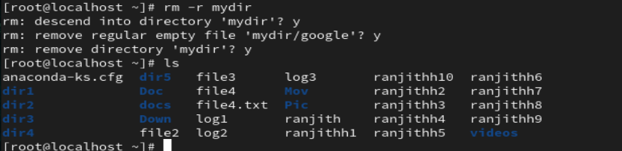
- Create a directory named `danger`.
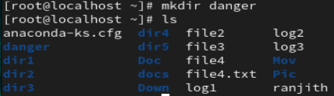

- Remove the `danger` directory forcefully.
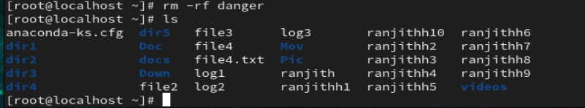
- Observe the difference between normal and forceful deletion.
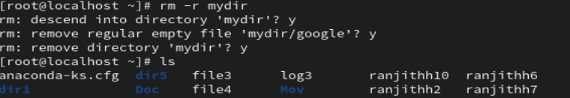

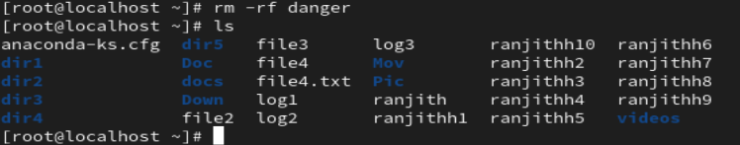

Lab -9
- Create a user named `linuxuser`.
- Switch to `linuxuser`.
- Create directories `work`, `test`, and `demo`.
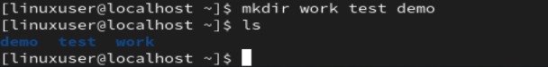
- Inside `work`, create files `a.txt`, `b.txt`, and `c.txt`.
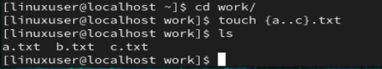
- List the files in detailed format.
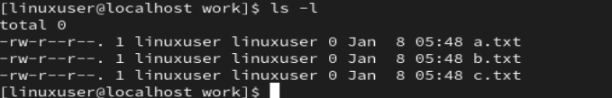
- Remove the files created.
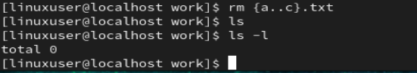
- Remove the `work` directory.
